Lesly Aimee Coca Reyes, grupo 39, sprint 6

Consola

Ejercicio 1
El comando o secuencia de comandos que te proporcionó los registros necesarios:
- $ ssh cnt-1fbc496e-bcc1-4e33-a0d1-0eeaa38da992@containerhub.tripleten-services.com -p 4554
- $ cd logs/2019/12
- $ grep -R 233.201

Registros:
apache_2019-12-11.txt:137.189.233.201 - - [11/12/2019:21:55:33 +0000] "PATCH /users HTTP/1.1" 401 3763
apache_2019-12-18.txt:233.201.188.154 - - [18/12/2019:21:46:01 +0000] "DELETE /events HTTP/1.1" 403 3971
apache_2019-12-21.txt:233.201.182.9 - - [21/12/2019:21:56:20 +0000] "PATCH /users HTTP/1.1" 400 4118

Ejercicio 2
Comandos que crean los directorios bug1 y events:
1. $ mkdir bug1
2. $ mkdir bug1/events
El comando que usas para seleccionar las solicitudes para un periodo especificado. Estas son las solicitudes que usas para obtener registros en el archivo main.txt:
$ grep “400” logs/2019/12/apache_2019-12-30.txt > bug1/main.txt
$ grep “500” logs/2019/12/apache_2019-12-30.txt > bug1/main.txt
Los comandos que usas para colocar los registros en los archivos 400.txt y 500.txt del main.txt:
$ grep "400" logs/2019/12/apache_2019-12-30.txt > bug1/events/400.txt
$ grep "500" logs/2019/12/apache_2019-12-30.txt > bug1/events/500.txt

400.txt
80.57.170.51 - - [30/12/2019:21:35:12 +0000] "DELETE /users HTTP/1.1" 400 3623
204.235.176.118 - - [30/12/2019:21:35:13 +0000] "POST /users HTTP/1.1" 400 4704
82.95.203.67 - - [30/12/2019:21:35:19 +0000] "DELETE /lists HTTP/1.1" 400 3737
155.242.215.46 - - [30/12/2019:21:35:38 +0000] "POST /playbooks HTTP/1.1" 400 4450
189.176.85.0 - - [30/12/2019:21:35:39 +0000] "PATCH /alerts HTTP/1.1" 400 2732
13.108.71.71 - - [30/12/2019:21:35:43 +0000] "PATCH /events HTTP/1.1" 400 3410
195.213.133.182 - - [30/12/2019:21:35:46 +0000] "PUT /customers HTTP/1.1" 400 3085
235.243.133.78 - - [30/12/2019:21:35:47 +0000] "PATCH /customers HTTP/1.1" 400 3264
192.57.115.49 - - [30/12/2019:21:35:55 +0000] "POST /parsers HTTP/1.1" 400 2457
71.0.49.244 - - [30/12/2019:21:35:55 +0000] "PUT /collectors HTTP/1.1" 400 2785
224.159.206.126 - - [30/12/2019:21:36:02 +0000] "DELETE /customers HTTP/1.1" 400 4569
131.35.106.246 - - [30/12/2019:21:36:04 +0000] "DELETE /lists HTTP/1.1" 400 2578
216.24.42.208 - - [30/12/2019:21:36:06 +0000] "GET /parsers HTTP/1.1" 400 4597
123.53.150.160 - - [30/12/2019:21:37:19 +0000] "PATCH /events HTTP/1.1" 400 4379
61.129.127.103 - - [30/12/2019:21:37:32 +0000] "GET /lists HTTP/1.1" 400 2575
90.216.4.78 - - [30/12/2019:21:37:34 +0000] "PATCH /lists HTTP/1.1" 400 3899
204.250.214.208 - - [30/12/2019:21:37:36 +0000] "PATCH /parsers HTTP/1.1" 400 4742
79.214.240.98 - - [30/12/2019:21:37:37 +0000] "POST /fieldsets HTTP/1.1" 400 4441
65.47.42.12 - - [30/12/2019:21:37:39 +0000] "PATCH /customers HTTP/1.1" 400 2500
251.118.141.34 - - [30/12/2019:21:37:41 +0000] "POST /customers HTTP/1.1" 400 3519
205.20.166.196 - - [30/12/2019:21:37:51 +0000] "POST /users HTTP/1.1" 400 4032
156.217.3.46 - - [30/12/2019:21:37:52 +0000] "PATCH /parsers HTTP/1.1" 400 2020
48.240.198.167 - - [30/12/2019:21:37:57 +0000] "PATCH /playbooks HTTP/1.1" 400 4100
101.255.159.211 - - [30/12/2019:21:37:59 +0000] "GET /auth HTTP/1.1" 400 2324
80.76.98.203 - - [30/12/2019:21:38:00 +0000] "POST /playbooks HTTP/1.1" 400 3045
85.64.63.255 - - [30/12/2019:21:38:13 +0000] "PATCH /collectors HTTP/1.1" 400 2291
184.79.247.161 - - [30/12/2019:21:38:13 +0000] "PUT /alerts HTTP/1.1" 400 3557
93.2.134.22 - - [30/12/2019:21:39:39 +0000] "DELETE /alerts HTTP/1.1" 400 3701
96.181.163.104 - - [30/12/2019:21:40:05 +0000] "GET /auth HTTP/1.1" 400 3742
214.73.245.219 - - [30/12/2019:21:40:07 +0000] "PATCH /customers HTTP/1.1" 400 2210
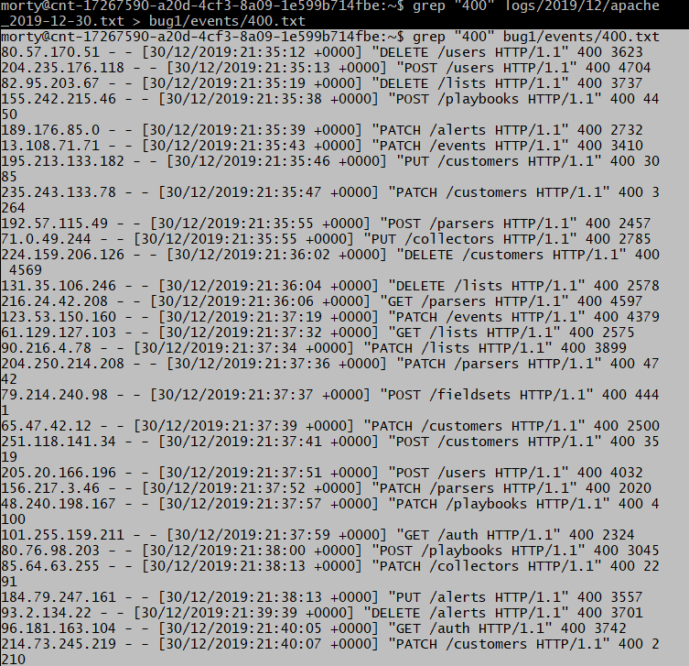
500.txt.
64.250.112.189 - - [30/12/2019:21:35:13 +0000] "PUT /parsers HTTP/1.1" 500 4639
193.253.101.180 - - [30/12/2019:21:35:31 +0000] "PATCH /alerts HTTP/1.1" 500 2944
197.106.117.194 - - [30/12/2019:21:35:31 +0000] "PATCH /parsers HTTP/1.1" 500 3519
247.124.71.67 - - [30/12/2019:21:35:45 +0000] "PUT /alerts HTTP/1.1" 500 2746
62.88.204.119 - - [30/12/2019:21:35:51 +0000] "PUT /auth HTTP/1.1" 500 2666
125.156.142.26 - - [30/12/2019:21:36:01 +0000] "PATCH /events HTTP/1.1" 500 3460
144.170.212.70 - - [30/12/2019:21:36:04 +0000] "DELETE /parsers HTTP/1.1" 500 2599
59.39.200.252 - - [30/12/2019:21:36:05 +0000] "GET /alerts HTTP/1.1" 500 2650
150.136.200.100 - - [30/12/2019:21:37:24 +0000] "POST /lists HTTP/1.1" 500 2684
84.81.25.45 - - [30/12/2019:21:37:25 +0000] "POST /auth HTTP/1.1" 500 2052
30.222.160.141 - - [30/12/2019:21:37:30 +0000] "PATCH /parsers HTTP/1.1" 500 2017
117.87.158.36 - - [30/12/2019:21:37:34 +0000] "POST /fieldsets HTTP/1.1" 500 4056
65.47.42.12 - - [30/12/2019:21:37:39 +0000] "PATCH /customers HTTP/1.1" 400 2500
212.153.128.212 - - [30/12/2019:21:37:42 +0000] "PUT /fieldsets HTTP/1.1" 500 3259
58.188.83.217 - - [30/12/2019:21:37:46 +0000] "POST /playbooks HTTP/1.1" 500 3947
193.123.131.146 - - [30/12/2019:21:37:47 +0000] "PUT /lists HTTP/1.1" 500 3902
182.7.179.91 - - [30/12/2019:21:37:48 +0000] "GET /users HTTP/1.1" 500 2950
10.25.168.164 - - [30/12/2019:21:38:05 +0000] "PATCH /playbooks HTTP/1.1" 500 3858
215.201.210.173 - - [30/12/2019:21:38:11 +0000] "PATCH /customers HTTP/1.1" 500 3277
179.241.103.167 - - [30/12/2019:21:39:23 +0000] "POST /lists HTTP/1.1" 500 3669
147.188.170.252 - - [30/12/2019:21:39:33 +0000] "POST /fieldsets HTTP/1.1" 500 3313
1.249.123.189 - - [30/12/2019:21:39:36 +0000] "PATCH /alerts HTTP/1.1" 500 4734
124.114.135.105 - - [30/12/2019:21:39:41 +0000] "PATCH /customers HTTP/1.1" 500 3348
35.215.100.202 - - [30/12/2019:21:39:43 +0000] "PUT /alerts HTTP/1.1" 500 4345
86.222.23.128 - - [30/12/2019:21:39:44 +0000] "PATCH /alerts HTTP/1.1" 500 2230
20.161.75.95 - - [30/12/2019:21:39:48 +0000] "DELETE /users HTTP/1.1" 500 2412
196.18.151.117 - - [30/12/2019:21:39:55 +0000] "PUT /events HTTP/1.1" 500 4439
77.101.138.151 - - [30/12/2019:21:39:57 +0000] "PUT /lists HTTP/1.1" 500 2194
1.178.37.101 - - [30/12/2019:21:40:08 +0000] "GET /customers HTTP/1.1" 500 4728
17.120.125.170 - - [30/12/2019:21:40:10 +0000] "PUT /events HTTP/1.1" 500 4283
61.18.173.115 - - [30/12/2019:21:40:14 +0000] "PUT /parsers HTTP/1.1" 300 4500
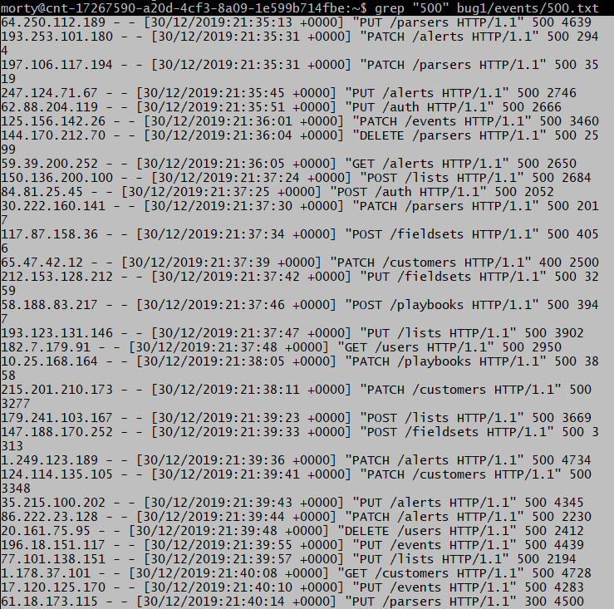

Base de datos

Ejercicio 1
Número de automóviles:
*5529
La solicitud que utilizaste para resolver la tarea.
* SELECT DISTINCT COUNT(vehicle_id) FROM cabs;

Ejercicio 2
Lista de las compañías con menos de 100 automóviles.
cnt | company_name
-----+----------------------------------------------
1 | 2733 - 74600 Benny Jona
53 | Chicago Medallion Leasing INC
1 | 5006 - 39261 Salifu Bawa
38 | Chicago Taxicab
20 | Metro Group
85 | Blue Diamond
1 | 3556 - 36214 RC Andrews Cab
80 | Chicago Medallion Management
8 | Metro Jet Taxi A
18 | Service Taxi Association
34 | Norshore Cab
81 | Checker Taxi Affiliation
1 | 3721 - Santamaria Express, Alvaro Santamaria
1 | 2809 - 95474 C & D Cab Co Inc.
1 | 2241 - 44667 - Felman Corp, Manuel Alonso
1 | 3620 - 52292 David K. Cab Corp.
1 | 2823 - 73307 Lee Express Inc
1 | 6057 - 24657 Richard Addo
8 | American United Taxi Affiliation
55 | American United
97 | Nova Taxi Affiliation Llc
La solicitud que te ayudó a resolver la tarea.
chicago_taxi=# SELECT COUNT(*) as cnt, company_name FROM cabs GROUP BY company_name HAVING COUNT (*) < 100;
usa \c chicago_taxi para entrar a la base de datos

Ejercicio 3
La tabla con los datos para el periodo especificado.
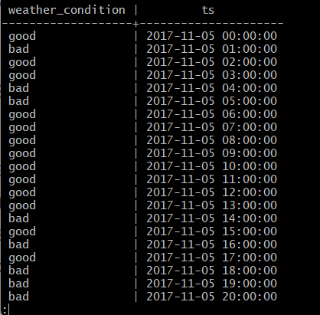
La solicitud que utilizaste para resolver la tarea.
SELECT CASE WHEN description LIKE '%rain%' THEN 'bad'
WHEN description LIKE '%storm%' THEN 'bad'
ELSE 'good'
END AS weather_condition,
ts
from
weather_records
where
ts >= '2017-11-05 00:00:00' and ts < '2017-11-06 00:00:00';

Ejercicio 4
La tabla con datos para un período específico.
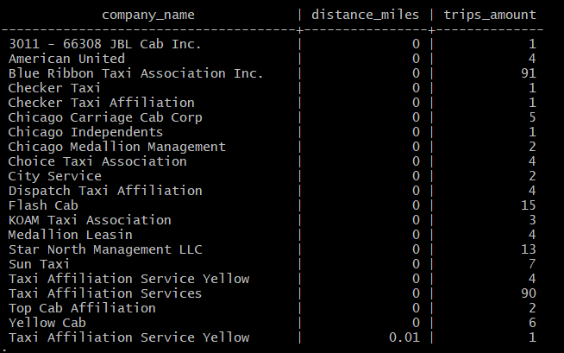
La solicitud que utilizaste para resolver la tarea.
SELECT
cabs.company_name,
trips.distance_miles,
COUNT (trips.trip_id) AS trips_amount
from trips INNER JOIN cabs ON cabs.cab_id = trips.cab_id
WHERE
start_ts >= '2017-11-15 00:00:00' and start_ts = '2017-11-15 00:00:00'
GROUP BY
trips.distance_miles,
cabs.company_name;

